Please follow the instructions below for recording your name using https://name-coach.com/events/sds-faculty-and-staff/recordings/new?entity_id=urn:mace:incommon:virginia.edu.
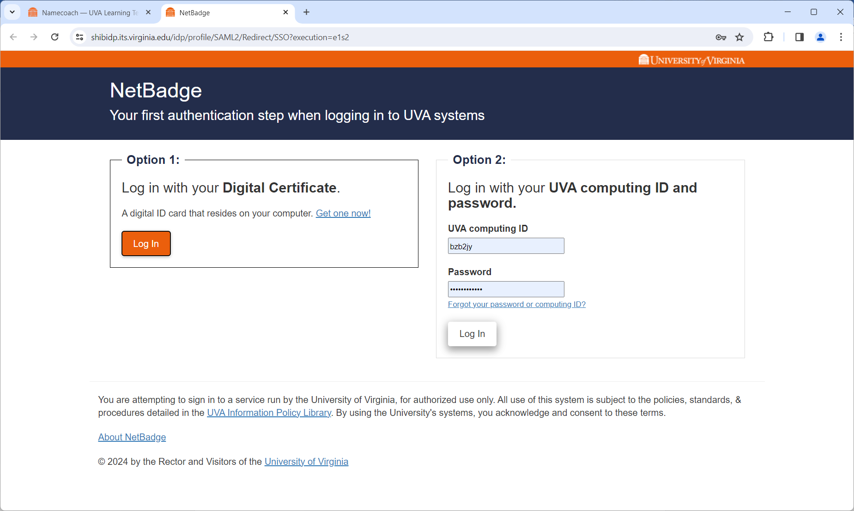
Insert your preferred pronouns (optional) and select an option for recording.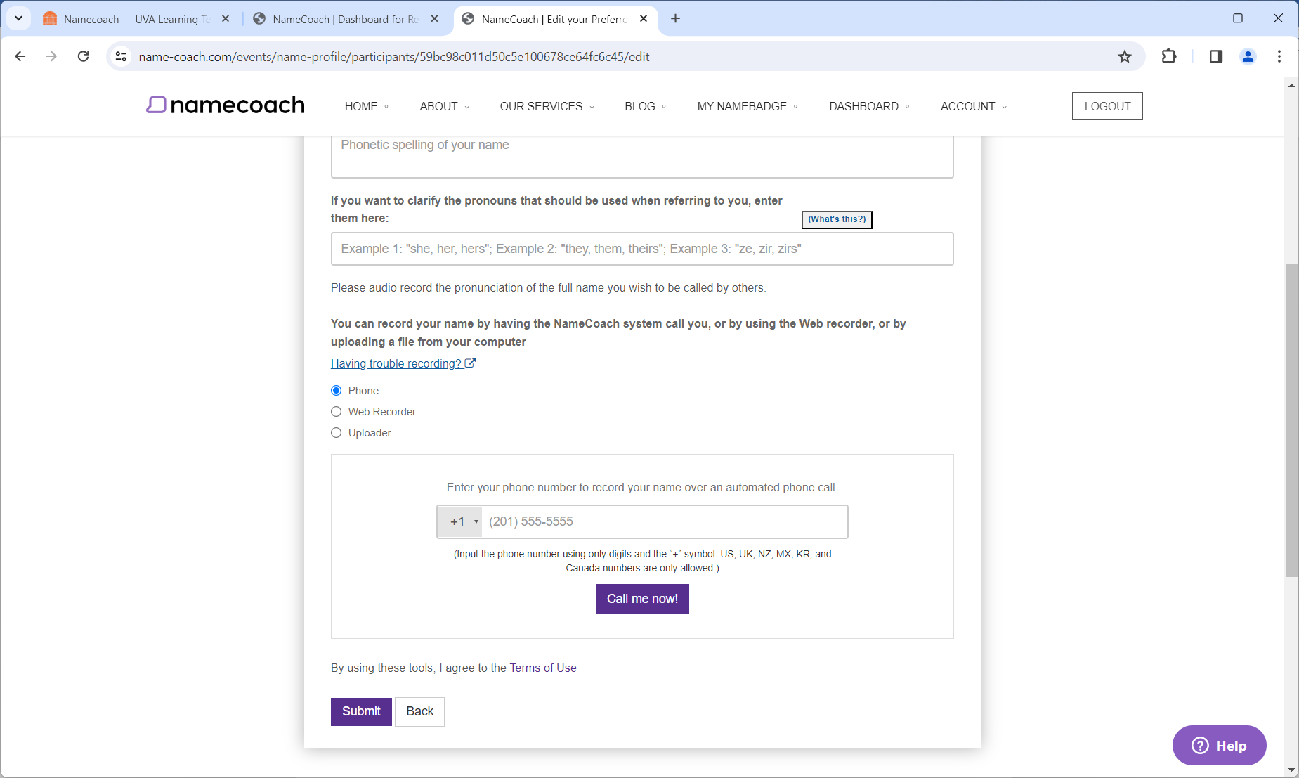Once the recording is submitted, you will be redirected to the Dashboard. Scroll past Your Recordings to get to Your NameBadge.
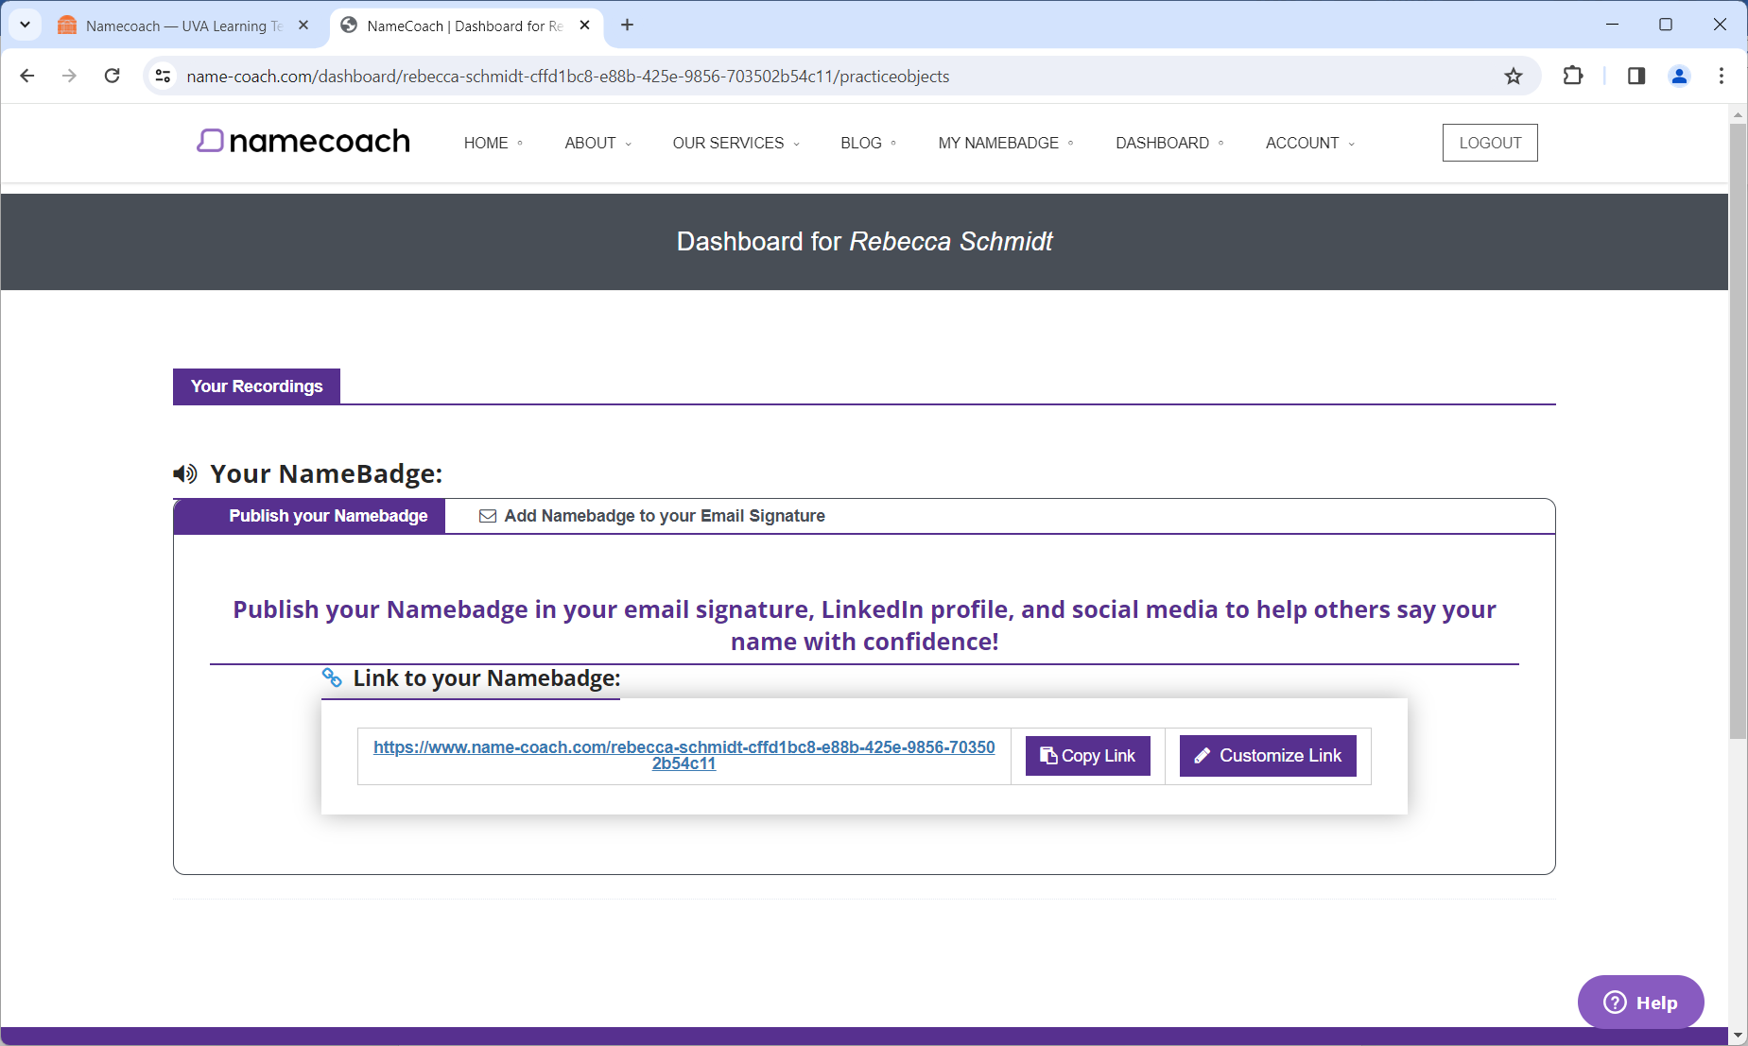
Use the “Add Namebadge to your Email Signature” subtab to copy your preferred option and add to your email signature in Outlook.
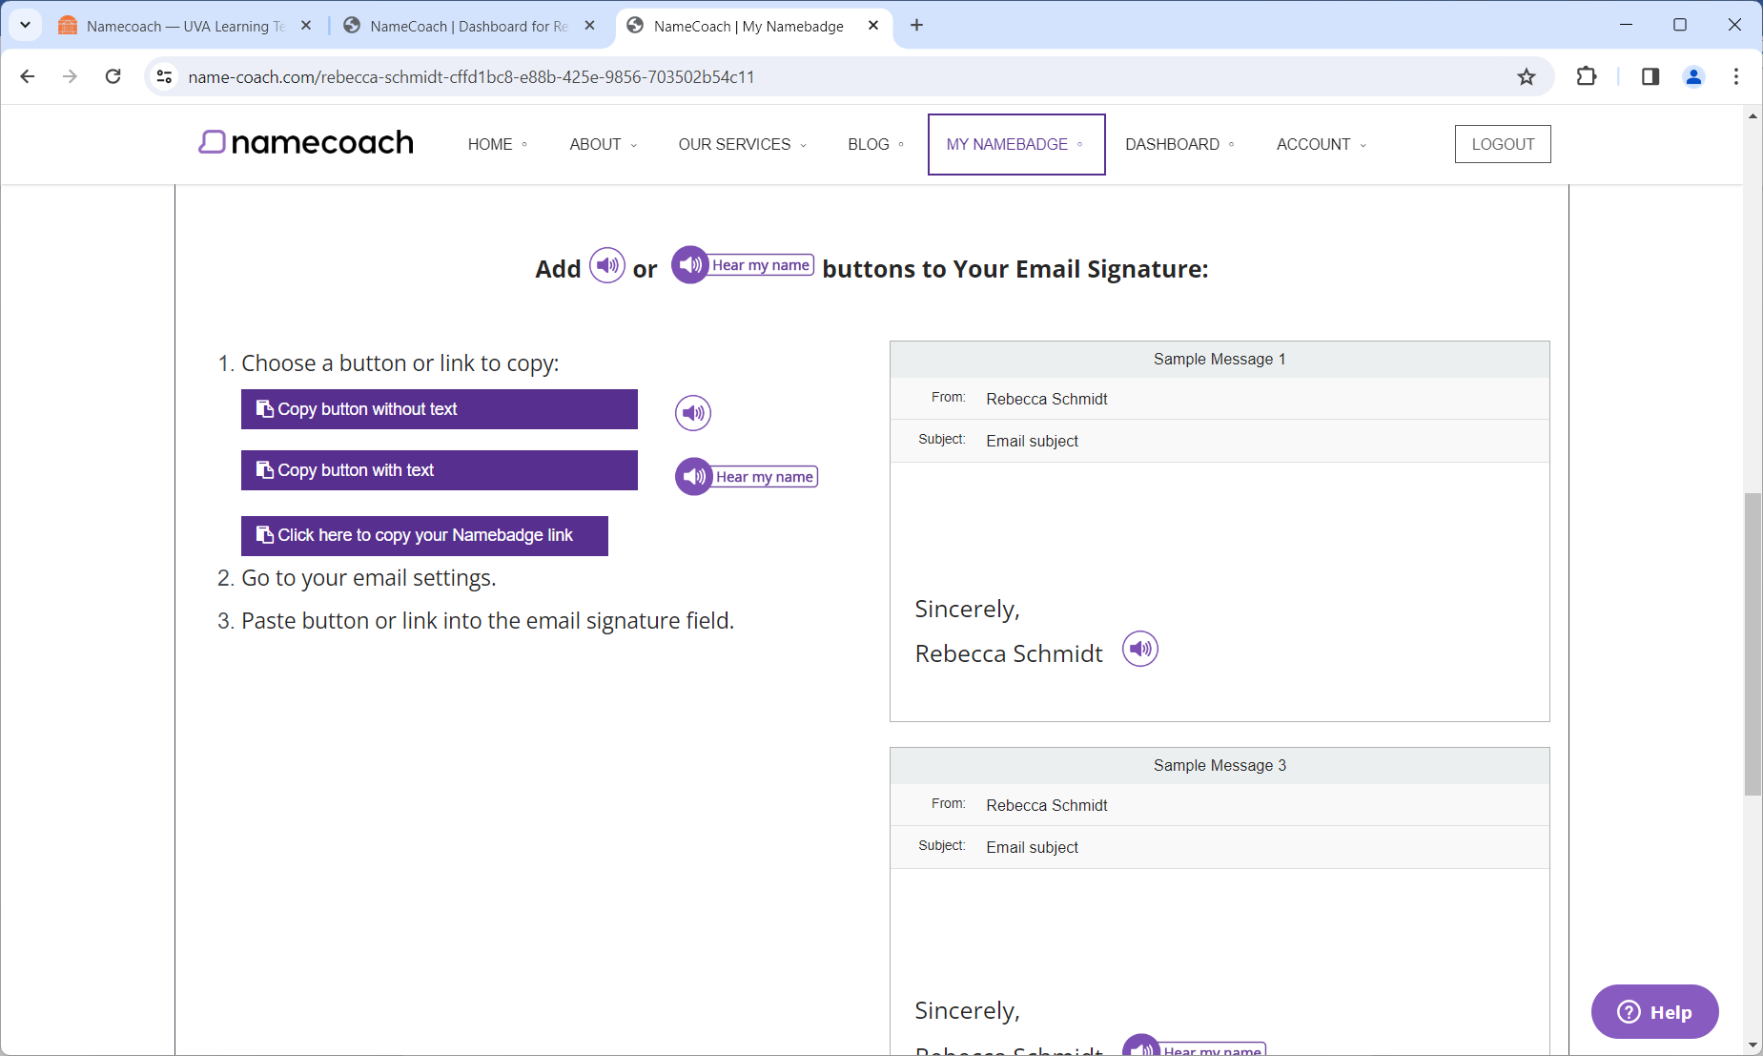
Open Outlook
Click on “File”
Select “Options” from the menu on the left
Select “Mail” from the menu on the left
Click on “Signatures”
Paste

